This document describes how RPCT Tuning Interface works.

To make parameters available for tuning, create an internal type signal in the Application Signals tab.

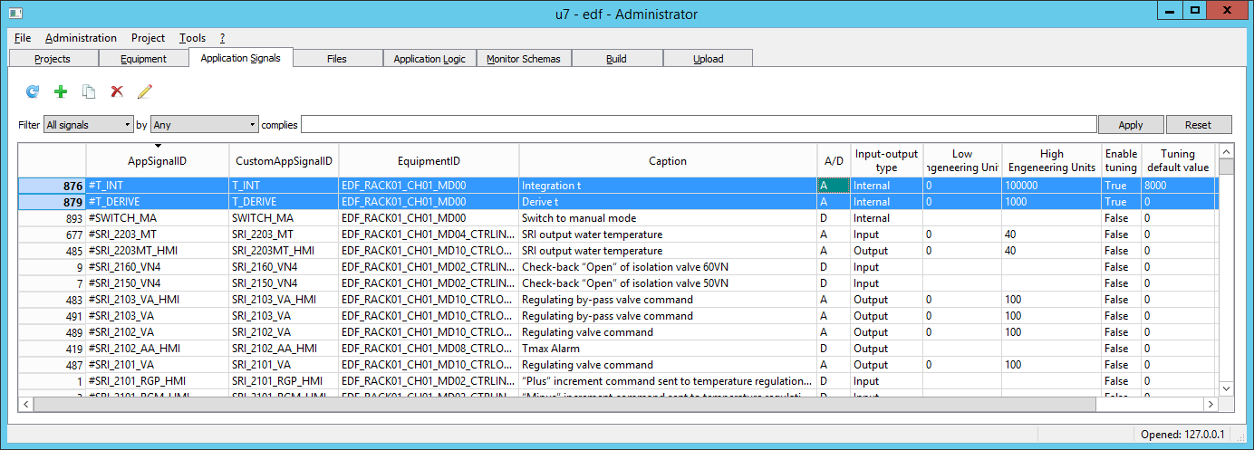

To enable tuning for a signal, set the "EnableTuning" option in the "Tuning" group in Signals properties dialog and set the "TuningDefaultValue" value for it. For analog signals it must be a value in the engineering units range, for discrete signals it must be 0 or 1.

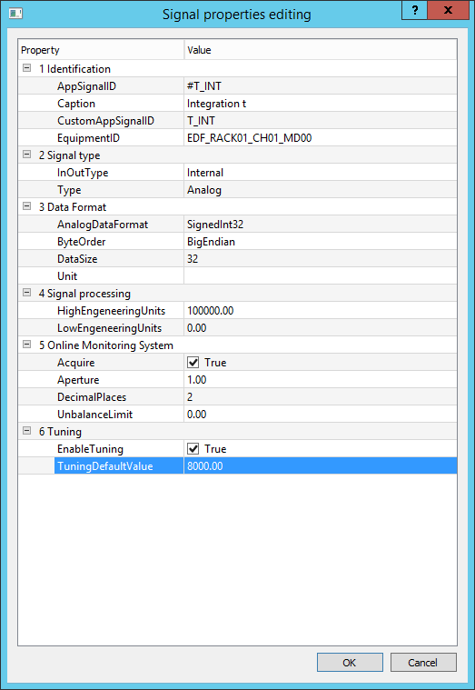 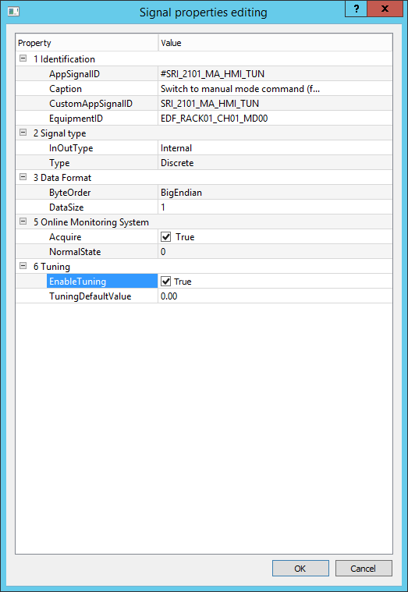

Tuning signals are placed to Application Logic schemas as usual signals.

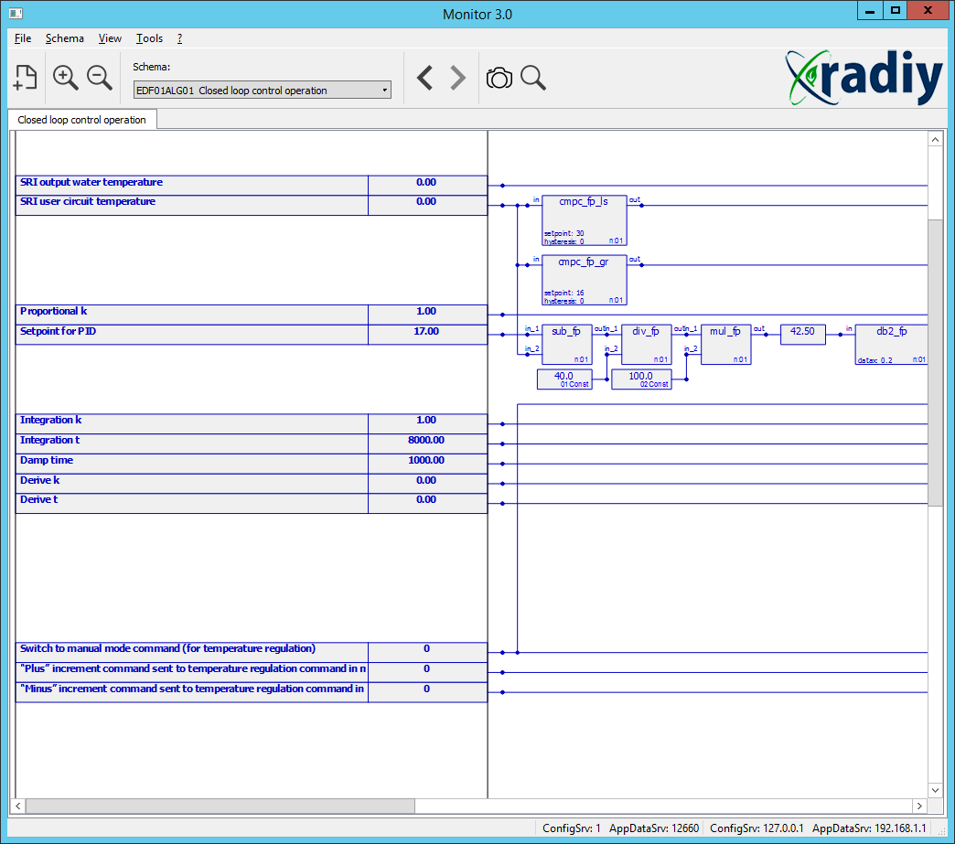

The next step is to configure the software in the "Equipment" tab page.

Two programs have to be added to the equipment tree: TuningClient and TuningService.

To configure TuningService, user must set up IP address of the interface that receives and sends the tuning data (TuningDataIP and TuningDataPort) and IP address of the interface that TuningClients connects to (ClientRequestIP, ClientRequestNetmask, ClientRequestPort).

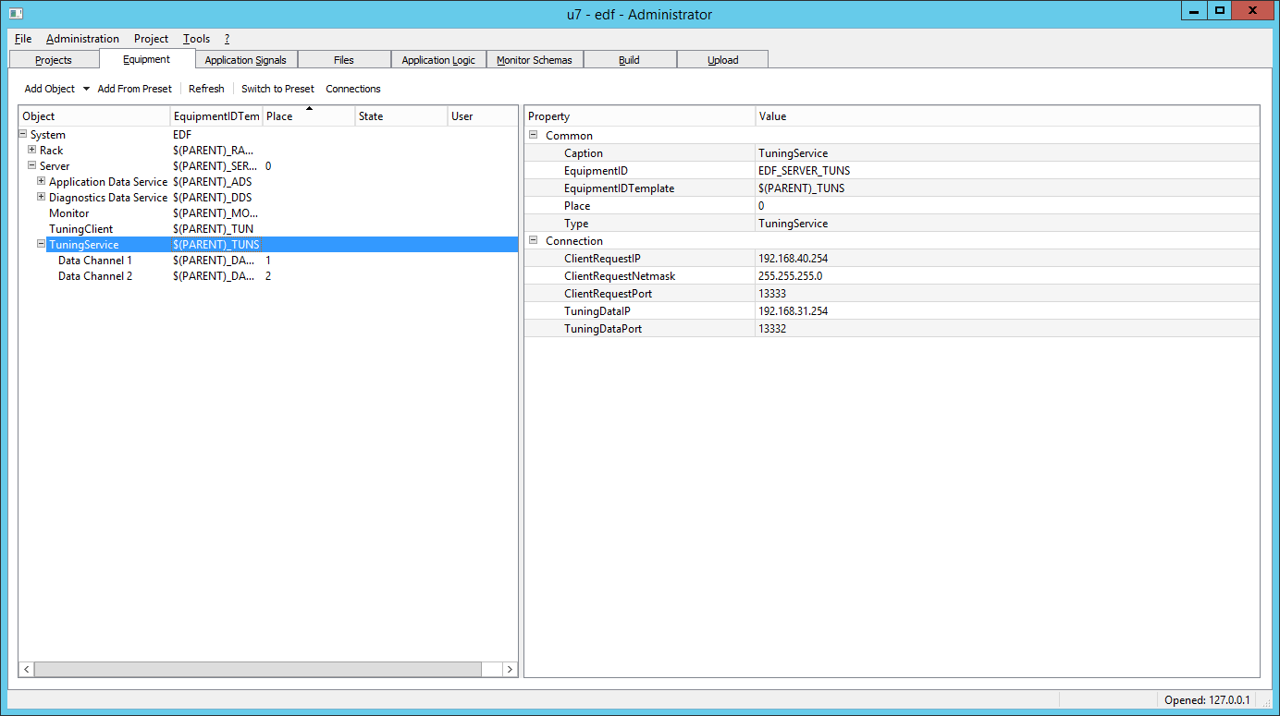

To configure TuningClient, user must specify the EquipmentID of Tuning Services (main and reserved) (TuningServiceID1, TuningServiceID2) and the list of the EquipmentIDs of logic modules, whose tuning signals are being processed by this client (TuningSourceEquipmentID).

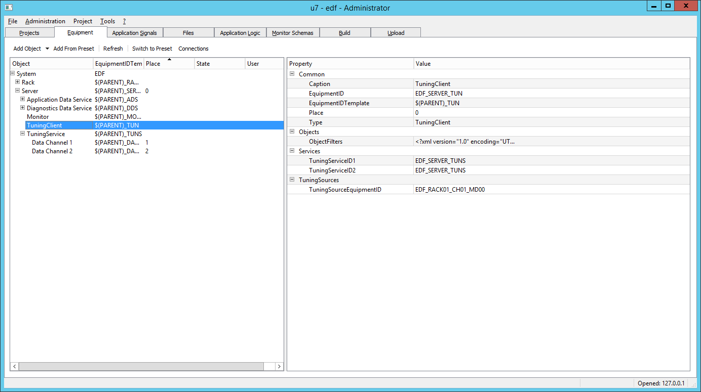

Next, generate the build, start TuningService and TuningClient applications.

The configuration window of the TuningClient is shown below. It contains EquipmentID of this client (Instance ID), IP addresses and ports of the Configuration service, and some options.

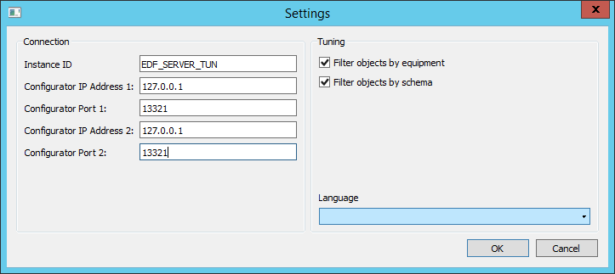

The main window of TuningClient is shown below.

On the left side it contains signals filters (by schema, by logic module and created by user) .

On the rignt side it contains a list of currently chosen tuning signals.

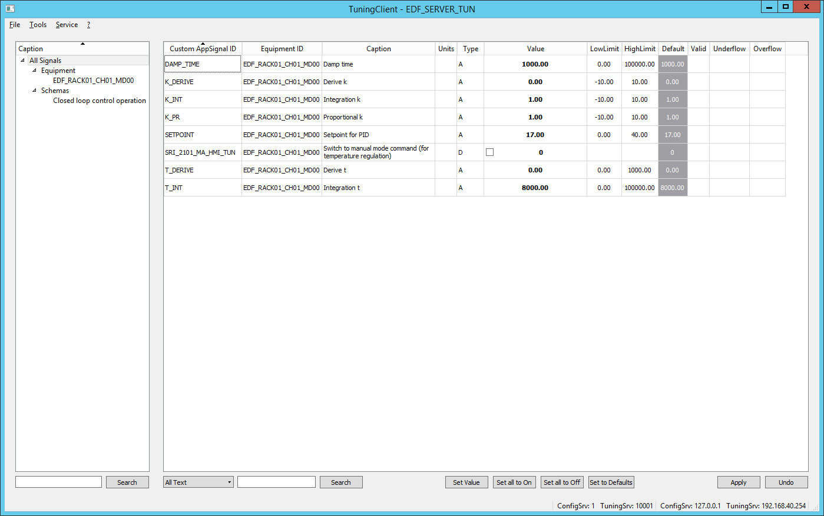

To change the value, click "Set value" button on the bottom or double click the mouse button on a signal. An input window will appear.

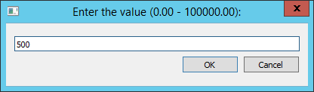

After clicking OK, the changed value will blink and will be highlighted by yellow. THE VALUE IS NOT WRITTEN to logic module yet!

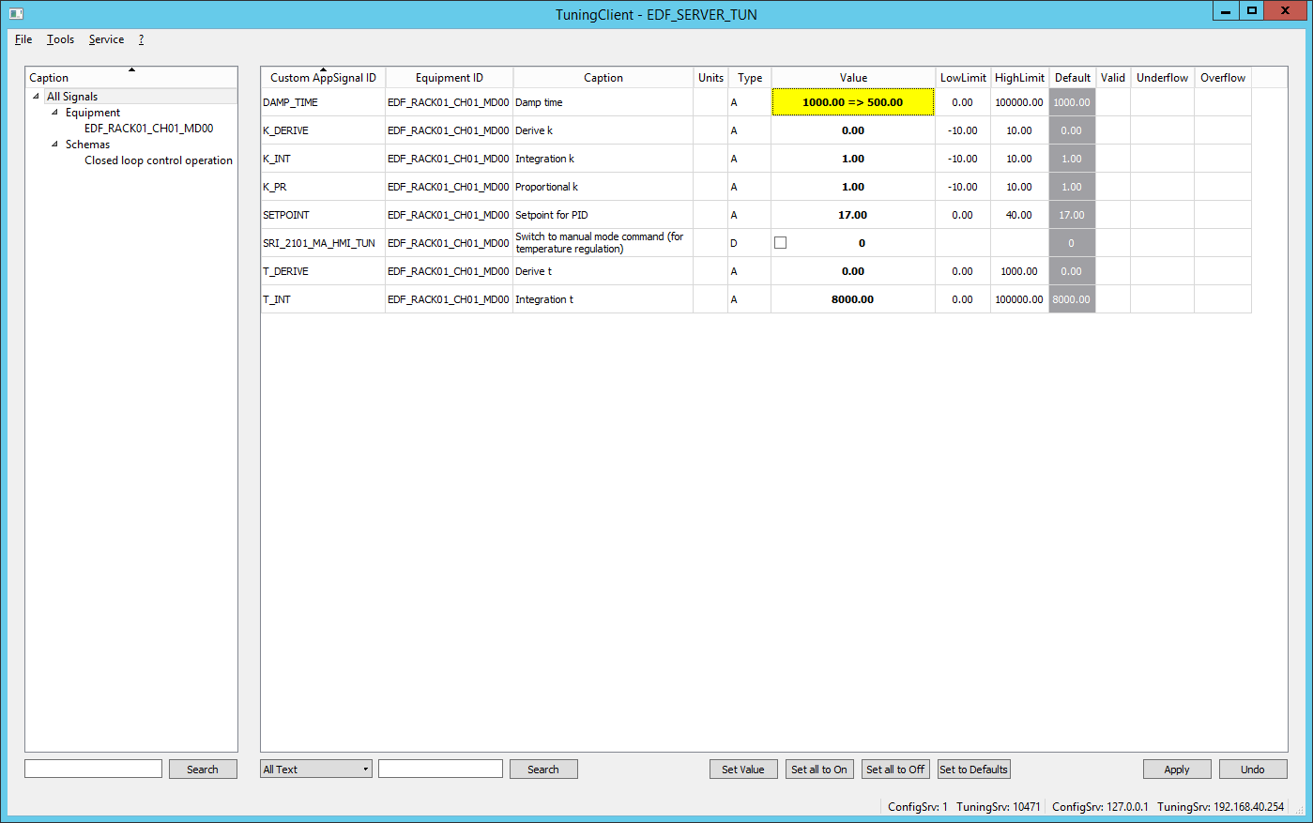

To apply changes and **write the data** **TO LOGIC MODULE**, press Apply button. The confirmation dialog will appear.

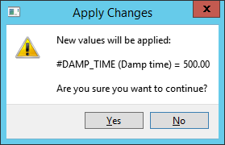

To change the value of a discrete signal, set the checkbox or press "Space" on the line in the list.

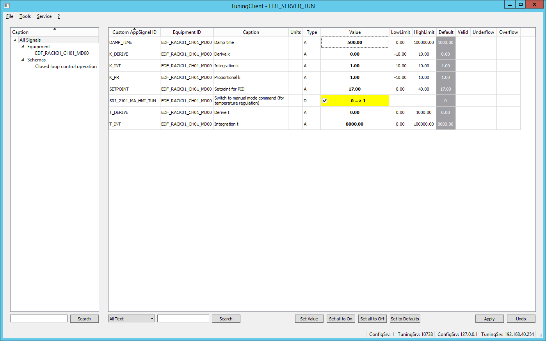

Then press "Apply" button.

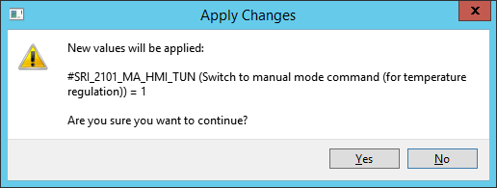

To filter signals by text fragment, enter the part of the identifier or caption in the edit box under signals list (e.g. "DAMP" below) and press "Search". Signals will be filtered.

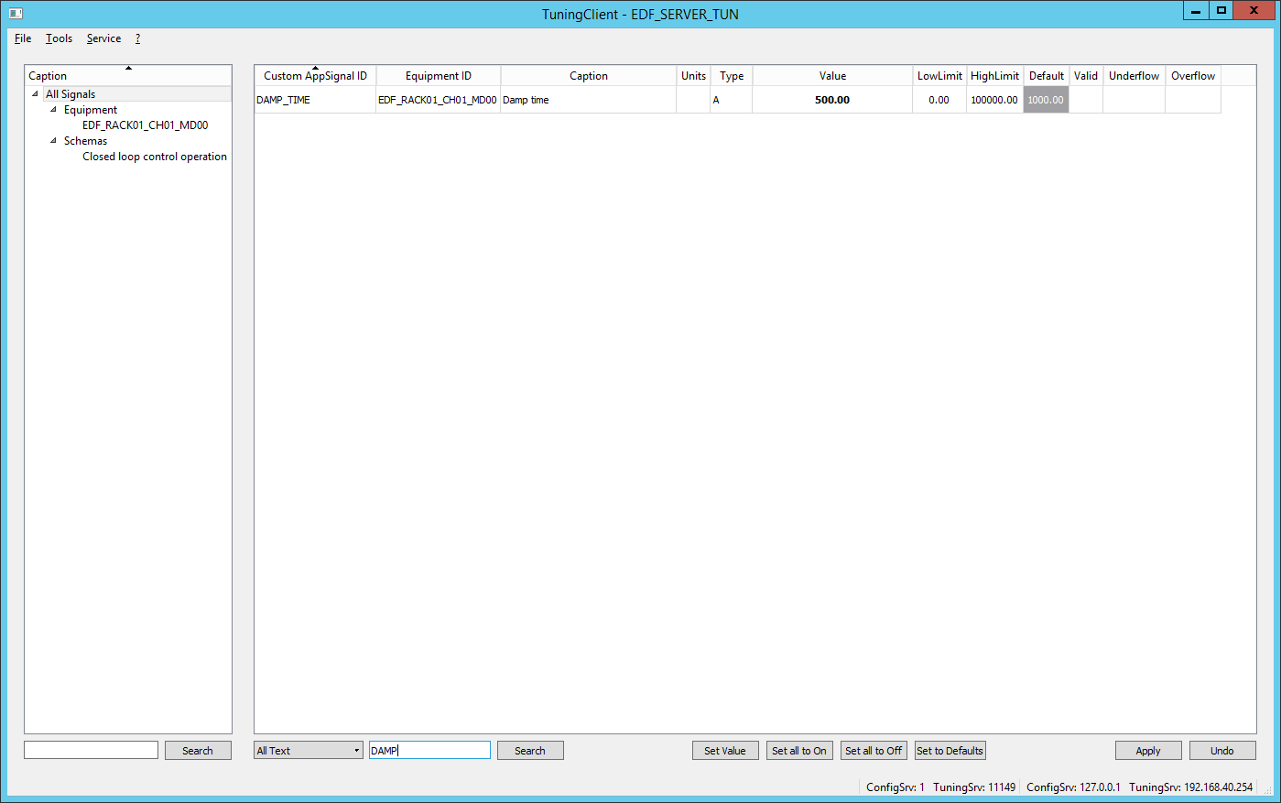

When data is not valid, all values are highilghted by red and displayed as "?".

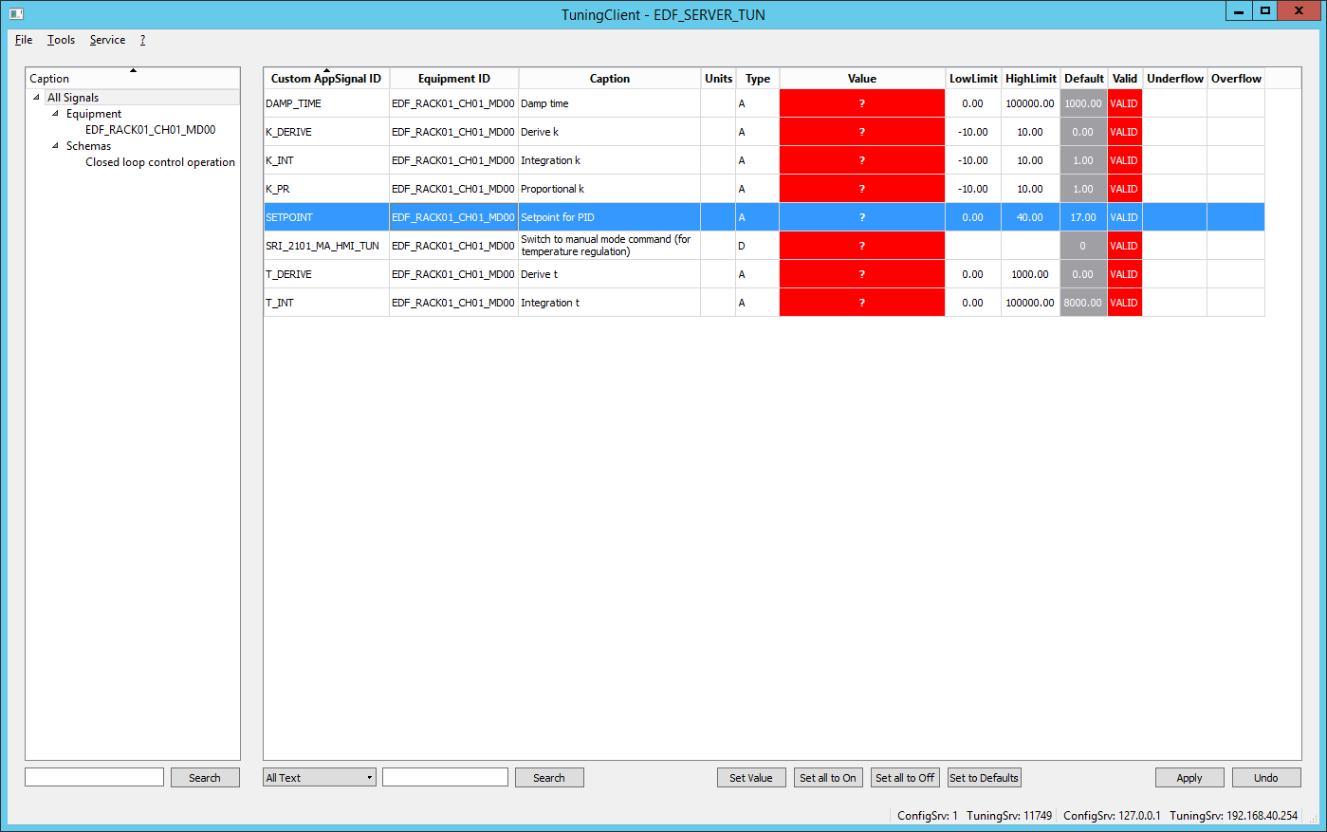

User can create custom signals presets. This is done by "Tools"-"Presets Editor" window.

Left side contains the list of tuning signals, the right side conatins presets.

To control presets, use "Add preset..."..."Remove preset", "Copy/Paste" buttons.

Presets can contain other presets and signals.

To add signals to preset, use "Add" button.

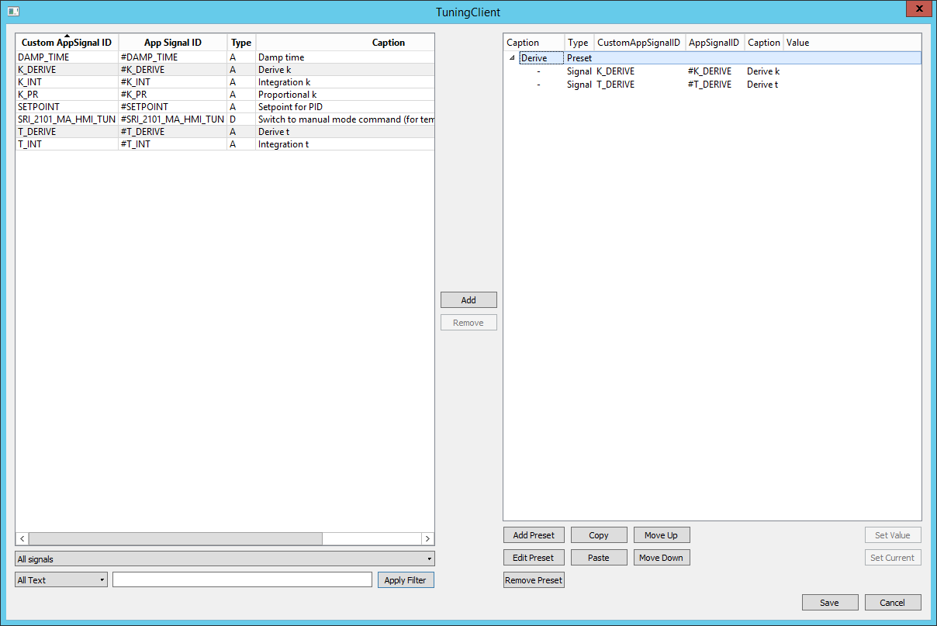

A preset has some properties: Caption, SignalType (analog or discrete or All), StrID(is not user-editable and is displayed for debugging) and identifier masks. This allows user to create presets that display only certain groups of signals.

Color property is used to create color backdround for tabs 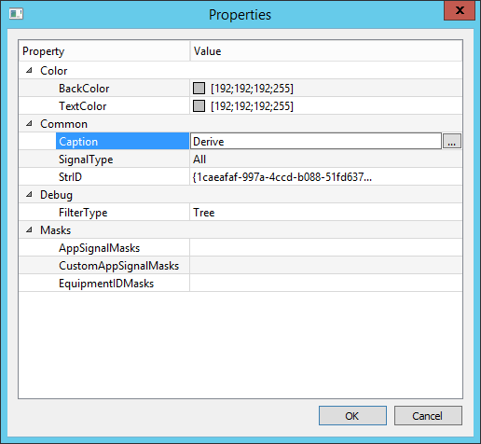

*(there is an example below from Rivne Nuclear Power Plant, locks and simulations, in Russian, only for understanding how color is used on tabs, tabs is an advanced option and is not user-editable now);*

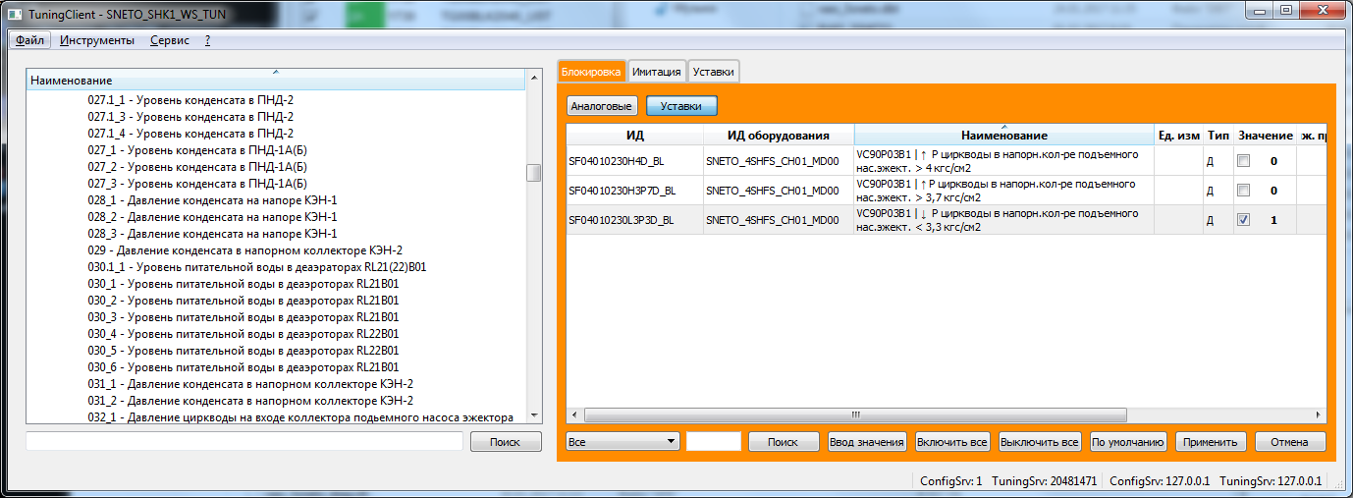

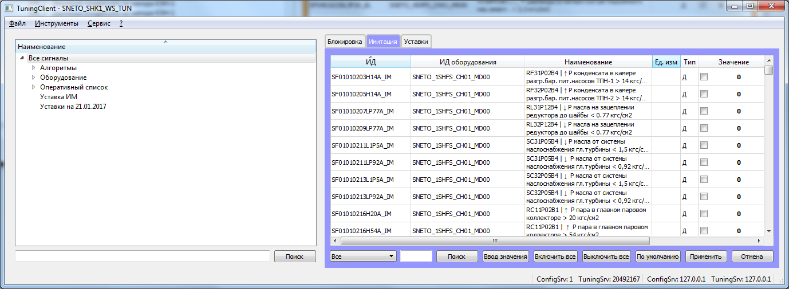

When the preset is selected, only signals contained in this preset are displayed.

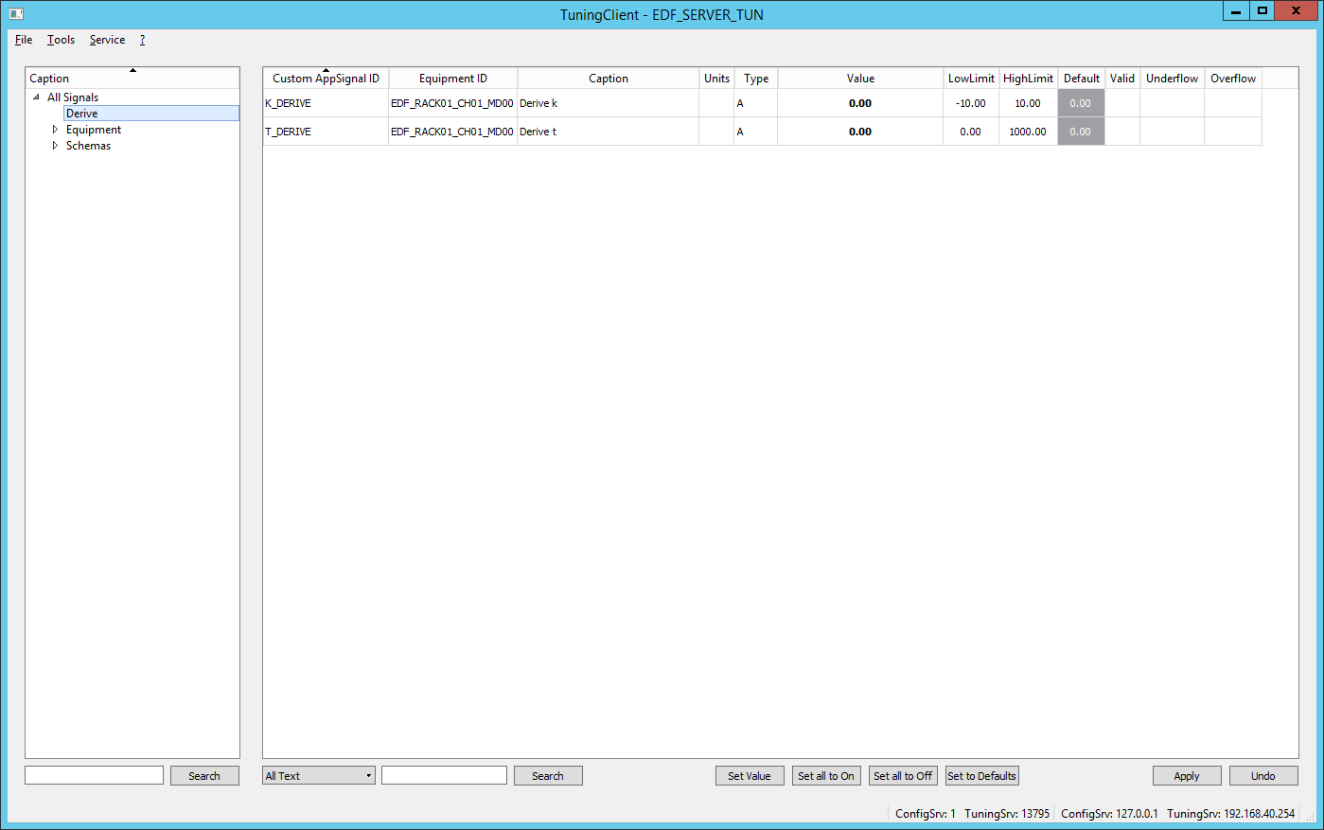

Preset signals may have predefined values.

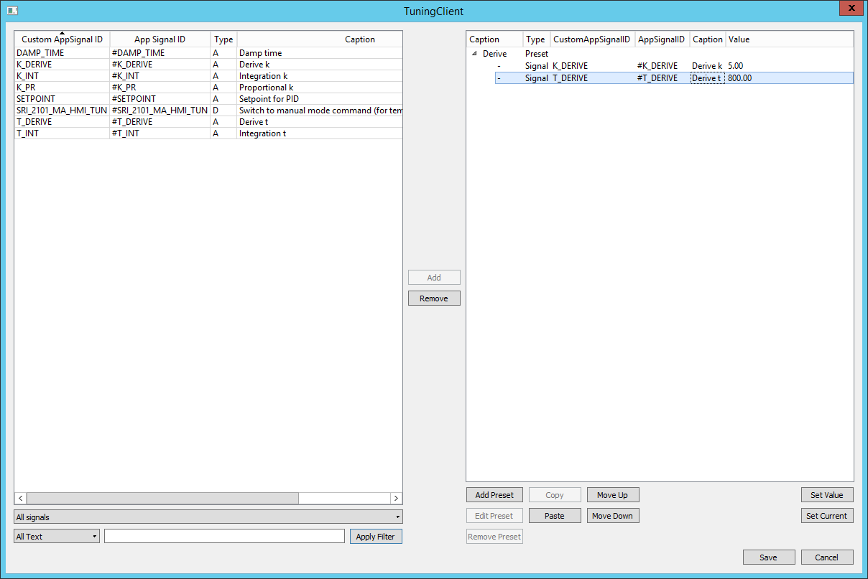

And they can be applied by "Set to Defaults" button.

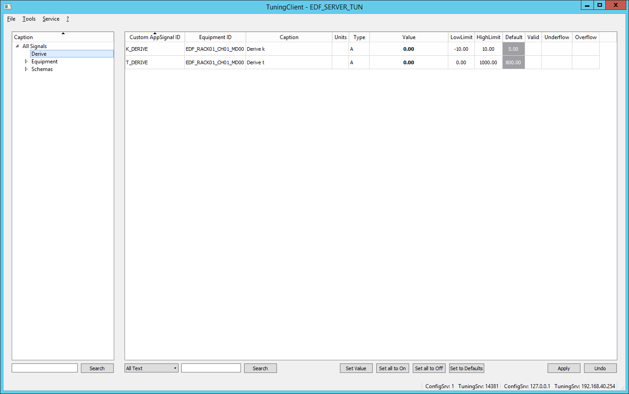

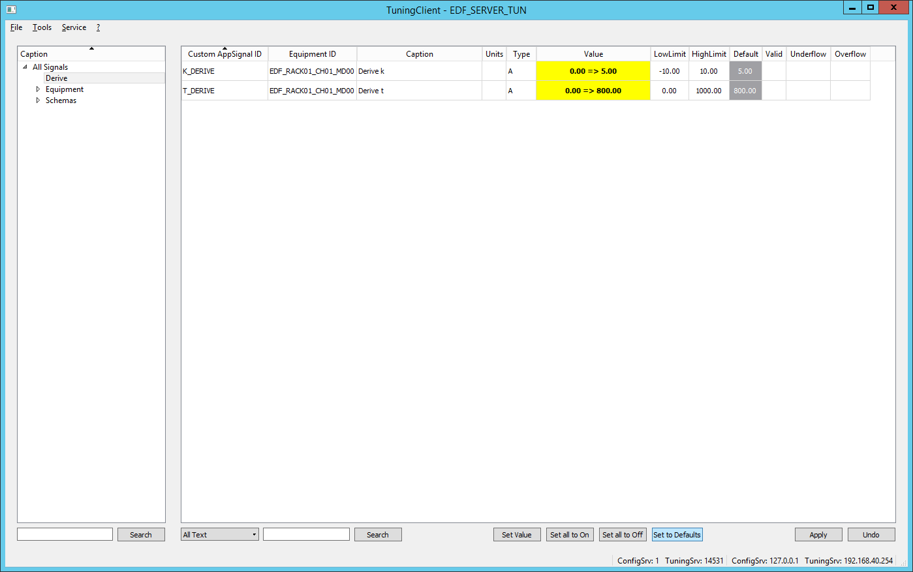

Tuning may be done by different users with password protection. This feature is under development, but some moments I can describe:

"Service"-"Users" calls the "Users" dialog, where user accounts can be added.

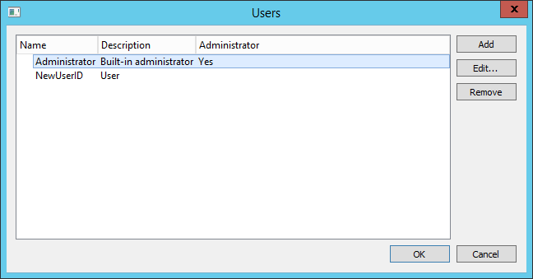

User properties editing dialog.

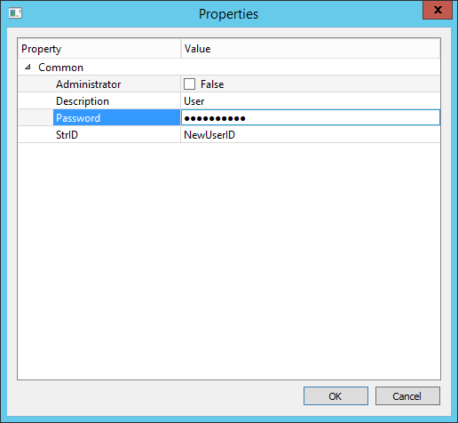

And when user tries to change the value and press "Apply", the following dialog appears.

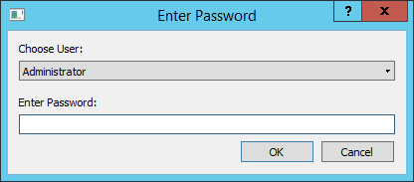

If password is wrong, the user will see a dialog:

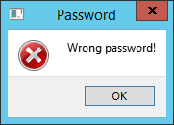

Otherwise, if it is correct, user Will be prompted to change values;

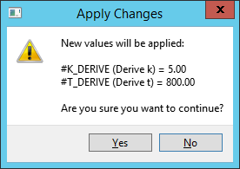

"Tools"->"Tuning sources" menu shows the information about current tuning sources state, "Details..." button shows detailed information about currently selected source.

